Software Design Specifications

Skillosity

Version: [1.4]

Project Code | CS-4092
Supervisor | Mr.Bahraj Khan
Co Supervisor | Mr. Shoaib Raza
Project Team | K18-1101 Hasan Salman  K18-0167 Zulfiqar Ahmed  K18-0206 Muhammad Hasan Aamir
Submission Date | 7/12/21

Document History
[Revision history will be maintained to keep a track of changes done by anyone in the document.]
Version | Name of Person | Date | Description of change
1.0 | Muhammad Hasan Aamir | 20/11/2021 | Document Created  Added Introduction
1.1 | Muhammad Hasan Aamir | 22/11/2021 | Added System and Software Architecture
1.2 | Muhammad Hasan Aamir | 1/12/2021 | Added Design Strategy
1.3 | Muhammad Hasan Aamir | 6/12/2021 | Added Class Diagram and Data Dictionary
1.4 | Muhammad Hasan Aamir | 22/12/2021 | Added ER Diagram, Sequence and State Diagrams  Completed SDS.

Distribution List

Name | Role
Mr.Bahraj Khan | Supervisor
Mr.Shoaib Raza | Co Supervisor

Document Sign-Off

Version | Sign-off Authority | Project Role | Signature | Sign-off Date
1.0
1.1
1.2
1.3
1.4

Document Information

Category | Information
Customer | FAST-NU
Project | Skillosity
Document | Software Design Specification
Document Version | 1.0
Status | Draft
Author(s) | Hasan Aamir, Hasan Salman, Zulfiqar Ahmed
Approver(s) | Shoaib Raza
Issue Date
Document Location | Department of Computer Science, FAST  National University, Karachi Campus
Distribution | Advisor  Project Coordinator’s Office (through Advisor)

Definition of Terms, Acronyms and Abbreviations

Term | Description
SQL | Structured Query Language
DB | Database
CSS | Cascaded style sheet
S | Stripe Payment Gateway
DBMS | Database Management System

Table of Contents
1 Introduction 7
1.1 Purpose of Document 7
1.2 Intended Audience 7
1.3 Document Convention 7
1.4 Project Overview 7
1.5 Scope 7
2 Design Considerations 8
2.1 Assumptions and Dependencies 8
2.2 Risks and Volatile Areas 8
3 System Architecture 9
3.1 System Level Architecture 9
3.2 Software Architecture 9
4 Design Strategy 10
5 Detailed System Design 11
5.1 Database Design 11
5.1.1 ER Diagram 12
5.1.2 Data Dictionary 13
5.1.2.1 User 13
5.1.2.2 User ( Seller ) 13.
5.1.2.3 Portfolio 14
5.1.2.4 User ( Buyer ) _______________________________________________________14.
5.1.2.2 Chat Contact 15.
5.1.2.2 Notifications 15.
5.1.2.2 Chats 16.
5.1.2.2 Products 16.
5.1.2.2 Category 17.
5.1.2.2 Admin 17.
5.1.2.2 Seller Feedback 18.
5.1.2.2 Buyer Feedback 18.
5.1.2.2 Complaint 19.
5.2 Application Design 20
5.2.1 Sequence Diagram 20
5.2.1.1 Seller Sequence Diagram 20
5.2.1.2 Buyer Sequence Diagram 21
5.2.1.3 Admin Sequence Diagram 22
5.2.2 State Diagram 23
5.2.2.1 Seller State Diagram 23
5.2.2.2 Buyer State Diagram 24
5.2.2.3 Admin State Diagram 25
6 References 26

Introduction

Purpose of Document
This system deals with the purchase of product that is made by using the natural skills of a person in music, animation or gaming online. This document covers details of the product, what is the problem and what solution it provides. The scope of this product is to allow people to use their natural skills to make innovative products and sell them online by safe and secure transactions.

Intended Audience
This system is an online platform for people who can use their natural skills to make their products and sell them and likewise the buyers can buy them. This SRS is intended for developers, sellers and buyers (general user).

Document Convention
The Document uses the following conventions:
- Font Size = 10
- Font = Arial

Project Overview

A web platform will be developed for people to sell their products using their natural skills they have in themselves.
There will be two types of user accounts: Seller and Buyers. The seller will be able to login and upload the demo of the product he has made using his/her natural skills in animation, gaming or music. The seller will have his own dashboard to keep track of his statistics. The buyer will be able to view the specification of a particular product and can buy the product. The product can be bought at a fixed price or negotiated price after chatting with the seller.
Seller will always be notified if someone has liked their product or want to buy them.
The transactions between the seller and buyer will be done using Stripe Payment Gateway through skillosity’s account. There will be a 7 day authentication period given to the buyer to check the product if it is what he saw on the platform.

Scope
The purpose of Skillosity is to let people with natural skills in animation, gaming and music sell their product and get instant payment. It also includes an easy-to-use web platform for buyers, who are willing to find innovative products.
The system is based on a relational database with seller’s skill based product. We will have a database server supporting the website and stripe payment gateway for safe and secure payment. Above all, we hope to provide a comfortable user experience along with innovative products and best pricing.

Design Considerations

Assumptions and Dependencies
We have created a single portal with single login and signup. In order for a buyer to be a seller as well, he has to make another account i.e. the seller account in order to sell a product.
The web platform is only available on the browser hence it is not an application for mobile.

Risks and Volatile Areas
Pitching an idea and discussing with others gives chances to others that they can copy the idea hence idea theft is a major risk to our system. Changes in user requirements are the major source due to which the system designs changes. The changes in requirements during the development phase make the design more complex and reduce the design’s flexibility.

System Architecture

System Level Architecture
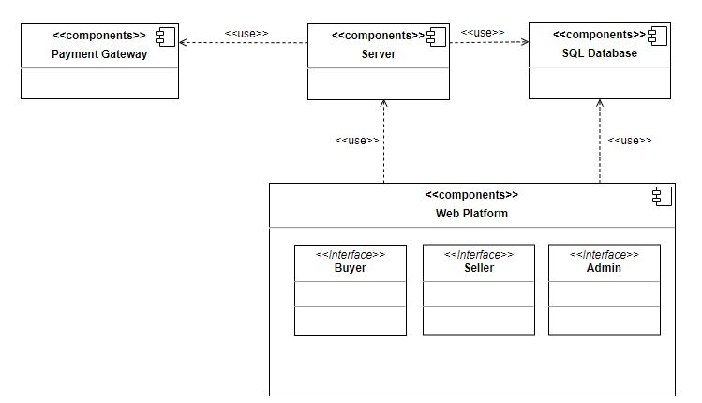

Software Architecture
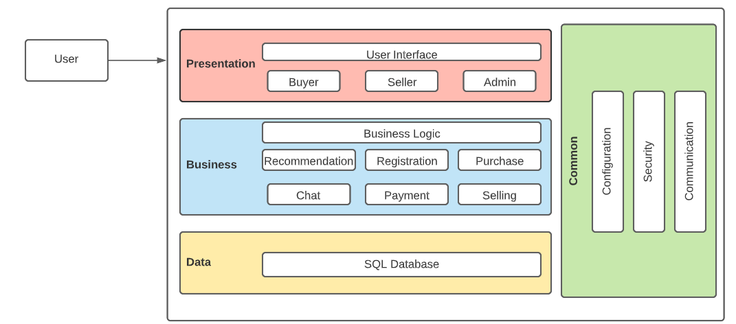

Design Strategy

The Frontend is developed using React JS. There will be a single web platform with users that can be buyers or sellers. Sellers can register, sign in and upload their digital products for sale. The buyer can view the details of the products and can buy it at fixed price or after negotiation in the chat as it is also available.

The Backend will be developed on Node JS. We will be using API of Stripe Payment Gateway to connect with the database so that the transactions between the buyer and seller can take place using skillosity’s stripe account.

There will be a single database i.e. SQL. SQL will store data of all the users, product and transactions.

The system will be designed in a modular manner to allow future extensions to be easily incorporated and in case of any modifications, only one module needs to be changed and it will not affect the whole system.

Encryption will be done on passwords to make the accounts secure. An OTP will be send on the user phone number to verify authenticity.

The Users will fall into two groups:
- Buyer
- Seller

We can cater to both these groups by designing effective search capabilities and navigation. The average Internet user has a low attention span and does not want to spend a lot of time going through hoops – especially if they know exactly what they are looking for. If your customer wants to buy a specific product, you want to make it as quick and painless as possible for them to find it. Anything else along the way is very rarely delightful and quite often distracting, or worse, off-putting. The human brain is constantly sorting and organizing things in trying to make sense of them. One way that we link one object to another is through their proximity to each other. Our web platform will offer great versatility and depth-of-choice that comes with purchasing.

Detailed System Design

Database Design
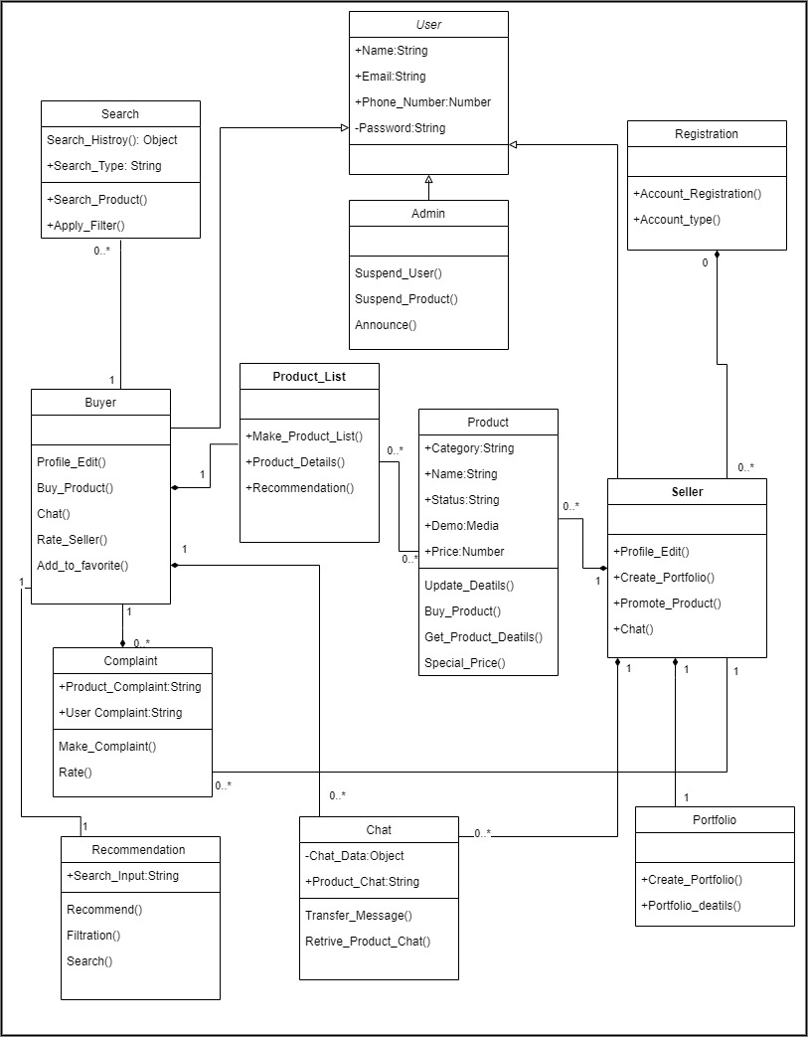

ER Diagram

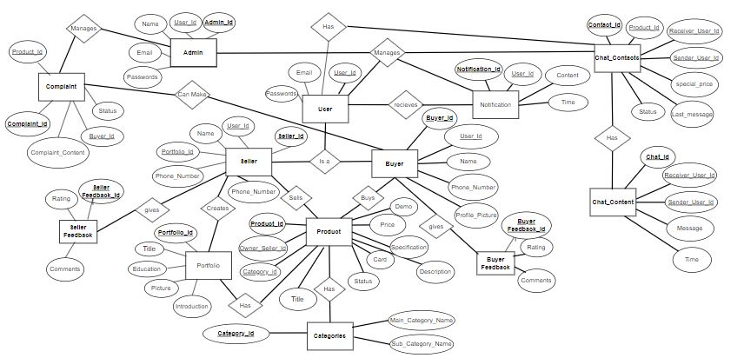

Data Dictionary

User
User
Name |  | User
Alias |  | -
Where-used/how-used |  | User of the platform
Content description |  | -
Column Name | Description |  | Type | Length | Null able | Default Value | Key Type
User_ID | Universal User ID for all users |  | VARCHAR | 20 | NO | - | PK
Email | Email of all users |  | VARCHAR | 20 | NO | -
Password | Password of the user |  | VARCHAR | 20 | NO | -

User (Seller)
Seller
Name |  | Seller
Alias |  | -
Where-used/how-used |  | Stores the data of the content seller
Content description |  | -
Column Name | Description |  | Type | Length | Null able | Default Value | Key Type
Seller_ID | ID of the seller |  | VARCHAR | 20 | NO | - | PK
User_ID | Universal User ID for all users |  | VARCHAR | 20 | NO | - | FK
Name | Name of the seller |  | VARCHAR | 35 | NO | -
Email | Email of the seller |  | VARCHAR | 35 | NO | -
Phone_number | Phone Number of the seller |  | Number | 20 | NO | -
Password | Seller’s Password |  | VARCHAR | 20 | NO | -
Portfolio_ID | Seller’s Portfolio |  | VARCHAR | 20 | NO | - | FK
Product_ID | ID of seller’s product. |  | VARCHAR | 20 | NO | - | FK

Portfolio
Portfolio
Name |  | Portfolio
Alias |  | -
Where-used/how-used |  | Portfolio of certain seller
Content description |  | -
Column Name | Description |  | Type | Length | Null able | Default Value | Key Type
Portfolio_ID | ID of Portfolio |  | VARCHAR | 20 | NO | - | PK
Title | Title or catch phrase for portfolio |  | VARCHAR | 50 | NO | -
Picture | Picture of portfolio |  | Media File | - | NO | -
Education | Education of the seller |  | VARCHAR | 1000 | NO | -
Introduction | Introduction of the seller |  | VARCHAR | 1000 | NO | -

User(Buyer)
User(Buyer)
Name |  | Buyer
Alias |  | -
Where-used/how-used |  | Stores the data of the content buyer
Content description |  | -
Column Name | Description |  | Type | Length | Null able | Default Value | Key Type
Buyer_Id | ID of the buyer |  | VARCHAR | 20 | NO | - | PK
Name | Name of the buyer |  | VARCHAR | 35 | NO | -
Email | Email of the Buyer |  | VARCHAR | 30 | NO | -
Phone_number | Buyer’s phone number |  | Number | 20 | NO | -
Password | Buyer’s Password |  | VARCHAR | 30 | NO | -

.
.

Chat_Contact
Chat_Contact
Name |  | Chat_Contact
Alias |  | -
Where-used/how-used |  | Chatting between users
Content description |  | -
Column Name | Description |  | Type | Length | Null able | Default Value | Key Type
Contact_ID | ID for contact between seller and buyer |  | VARCHAR | 20 | NO | - | PK
Sender_User_ID | User ID of Sender |  | VARCHAR | 20 | NO | - | FK
Receiver_User_ID | User ID of receiver |  | VARCHAR | 20 | NO | - | FK
Product_ID | ID of the Product, chat about which product |  | VARCHAR | 20 | NO | - | FK
Last_message | Last message seen by any of the user i.e seller and buyer |  | VARCHAR | 1000 | YES | -
Status | Status of the chat i.e (Closed or not)
Special_Price | Certain Price for the buyer |  | NUMBER | 6 | YES | -

Notifications
Notifications
Name |  | Notification
Alias |  | -
Where-used/how-used |  | Notifications to notify people about the information regarding product.
Content description |  | -
Column Name | Description |  | Type | Length | Null able | Default Value | Key Type
Notification_ID | ID of notification |  | VARCHAR | 20 | NO | - | PK
User_Id | ID of the user |  | VARCHAR | 20 | NO | -
Content | Product Content |  | VARCHAR | 1000 | NO | -
Time | Time of Notification |  | Time | 5 | NO | -

Chats
Chats
Name |  | Chats
Alias |  | -
Where-used/how-used |  | Chat content of the users
Content description |  | -
Column Name | Description |  | Type | Length | Null able | Default Value | Key Type
Chat_ID | ID of Chat |  | VARCHAR | 20 | NO | - | PK
Contact_ID | Which user is contacting which user |  | VARCHAR | 20 | NO | - | FK
Content | Content sending to the receiver user |  | File | - | NO | -
Time | Chat Time |  | VARCHAR | 20 | NO | -

Products
Product
Name |  | Product
Alias |  | -
Where-used/how-used |  | The content to be sold by the seller and bought by the buyer.
Content description |  | -
Column Name | Description |  | Type | Length | Null able | Default Value | Key Type
Product_ID | ID of Product |  | VARCHAR | 20 | NO | - | PK
Title | Product’s Title |  | VARCHAR | 30 | NO | -
Thumbnail | Product’s Thumbnail |  | VARCHAR | 20 | NO | -
Price | Product’s Price |  | Number | 15 | NO | -
Specification | Specification of the Product |  | VARCHAR | 1000 | NO | -
Description | Description of the Product |  | VARCHAR | 1000 | NO
Owner_Seller_ID | ID of the seller selling the product |  | VARCHAR | 30 | NO |  | FK
Status | Status of the Product |  | VARCHAR | 20 | NO | -
Demo | Demo of the product |  | Media file
Category_ID | Category ID of the Product |  | VARCHAR | 20 | NO | - | FK

Category
Category
Name |  | Notification
Alias |  | -
Where-used/how-used |  | The categories of the products.
Content description |  | -
Column Name | Description |  | Type | Length | Null able | Default Value | Key Type
Category_ID | Category ID |  | VARCHAR | 20 | NO | - | PK
Main_Name | Name of the Category |  | VARCHAR | 20 | NO | -
Sub_Category_Name | Sub Categories |  | VARCHAR | 20 | NO | -

Admin
Admin
Name |  | Admin
Alias |  | -
Where-used/how-used |  | The manager of the whole system
Content description |  | -
Column Name | Description |  | Type | Length | Null able | Default Value | Key Type
Admin_ID | ID of admin |  | VARCHAR | 20 | NO | - | PK
Name | Name of the Admin |  | VARCHAR | 20 | NO | -
User_ID | UserID of Admin |  | VARCHAR | 20 | NO | -
Privileges | Privileges of Admin |  | VARCHAR | 20 | NO | -

Seller Feedback
Seller Feedback
Name |  | Seller Feedback
Alias |  | -
Where-used/how-used |  | To give feedback about the buyer.
Content description |  | -
Column Name | Description |  | Type | Length | Null able | Default Value | Key Type
Seller_Feedback_Id | ID of seller feedback |  | VARCHAR | 20 | NO | - | PK
Comment | Comments |  | VARCHAR | 100 | NO | -
User_ID | UserID of Buyer |  | VARCHAR | 20 | NO | - | FK
Rating | Rating Of Buyer |  | Char | 5 | NO | -

Buyer Feedback
Buyer Feedback
Name |  | Buyer Feedback
Alias |  | -
Where-used/how-used |  | To give feedback about the Seller.
Content description |  | -
Column Name | Description |  | Type | Length | Null able | Default Value | Key Type
Buyer_Feedback_Id | ID of buyer feedback |  | VARCHAR | 20 | NO | - | PK
Comment | Comments |  | VARCHAR | 100 | NO | -
User_ID | UserID of Seller |  | VARCHAR | 20 | NO | - | FK
Rating | Rating Of Seller |  | Char | 5 | NO | -

Complaint
Complaint
Name |  | Complaint
Alias |  | -
Where-used/how-used |  | To Complain
Content description |  | -
Column Name | Description |  | Type | Length | Null able | Default Value | Key Type
Complaint_ID | ID of complain |  | VARCHAR | 20 | NO | - | PK
Buyer_Id | Buyer that is complaining |  | VARCHAR | 20 | NO | - | FK
Prodcut_ID | Id of Product |  | VARCHAR | 20 | NO | - | FK
Complaint_Content | Description |  | VARCHAR | 200 | NO | -
Status | Status of Complaint |  | VARCHAR | 10 | NO | -

Application Design

Sequence Diagram

Seller Sequence Diagram

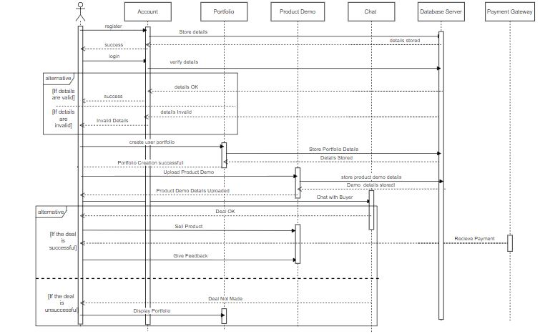

Buyer Sequence Diagram
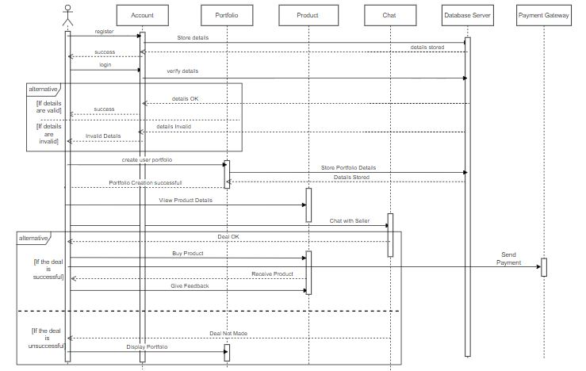

.
.

Admin Sequence Diagram

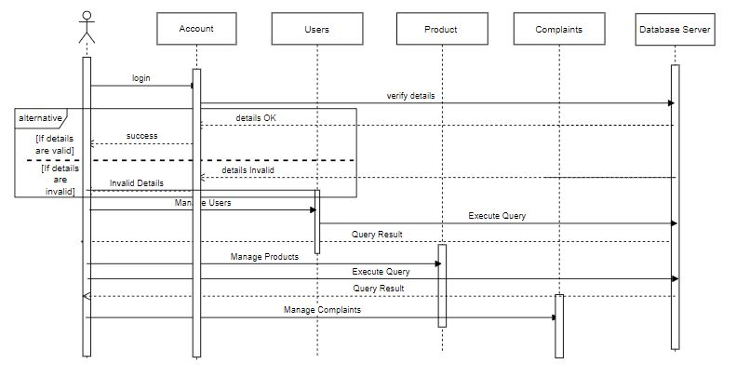

State Diagram

Seller State Diagram

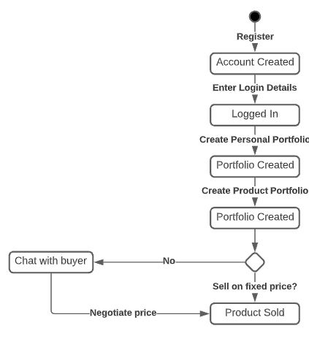

Buyer State Diagram

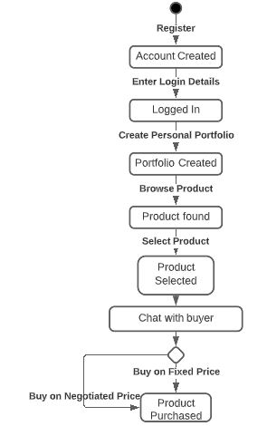

Admin State Diagram
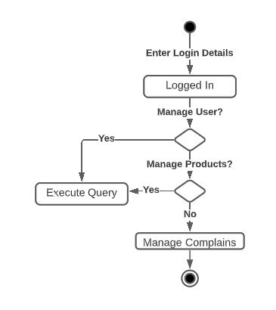

References

- Node.js
https://nodejs.org/en/docs/
- React.js
https://reactjs.org/docs/getting-started.html
- Stripe payment gateway:
https://stripe.com/docs/api
- Amazon Web services:
https://aws.amazon.com/getting-started/hands-on/build-react-app-amplify-graphql/
- NPM Packages
https://docs.npmjs.com/about-npm/
- Material Ui
https://mui.com/getting-started/usage/

